**Teacher notes: using parallel box and whisker plots to compare results for treatments in visual impairment challenges**

**BOX AND WHISKER PLOTS**

A box and whisker plot is a way of summarizing a set of data measured on an interval scale. It is often used in explanatory data analysis to compare two or more numerical datasets. They are especially useful for indicating whether a distribution is skewed and whether there are potential unusual observations (outliers) in the data set (Statistics Canada, 2016). A single axis can be used to compare multiple datasets.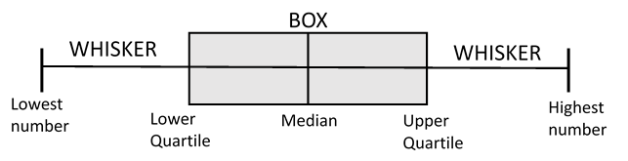

**Figure 3 –** Elements of a Box and Whisker plot

A box and whisker plot graphically represents a 5 number summary of your data. It summarises your data when all of your observations are sorted from lowest to highest. The 5 number summary includes

1. the lowest number in your dataset,
2. the lower quartile (the median of the lower half of your dataset),
3. the median (the middle number in your dataset),
4. the upper quartile (the median of the top half of your dataset)
5. the highest number in your dataset

**Creating your own box and whisker plots of data using the online *Boxplot Grapher* tool.**

Available at: <http://www.imathas.com/stattools/boxplot.html>, last accessed 6th May 2016.

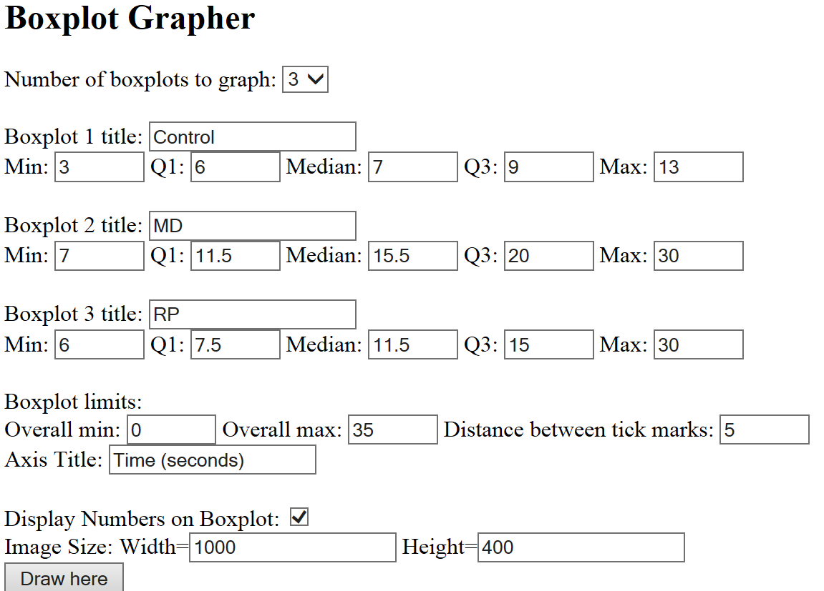

**Figure 4** – Boxplot Grapher software

You can create your own box plots quickly by entering your five number summaries for each condition into the *Boxplot Grapher* software. Title your boxplots respectively for the control condition, Macular Degeneration and Retinitis Pigmentosa. To get a graph of a decent size, set the **image width** to 1000 and the **height** to 400.

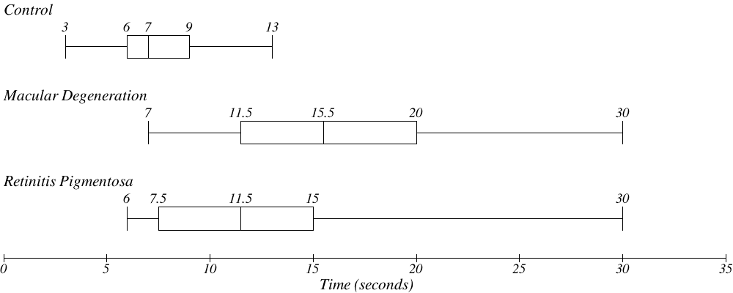

**Figure 5** – Parallel box plots representing the datasets for time taken to complete tasks for two stations in the visual impairment experience challenges with the Macular Degeneration and Retinitis Pigmentosa visual impairment googles, as well as without visual impairment goggles created with Boxplot Grapher.